Matter Expense
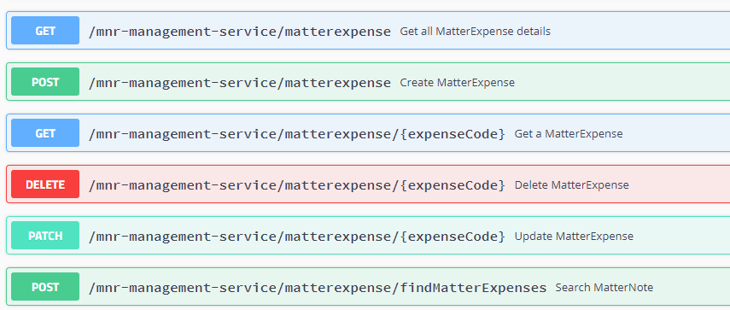

Matter FeeSharing
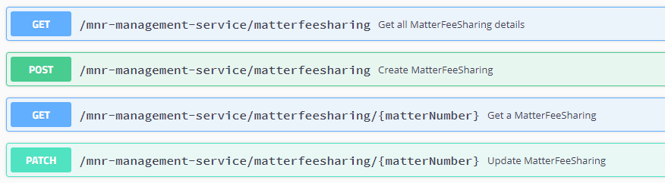
Matter-Accounting
Matter Intake
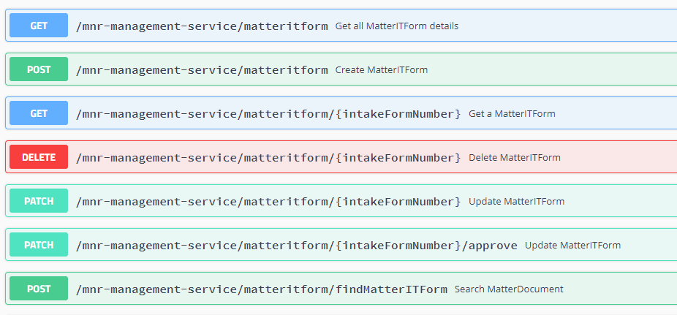
Matter Rate
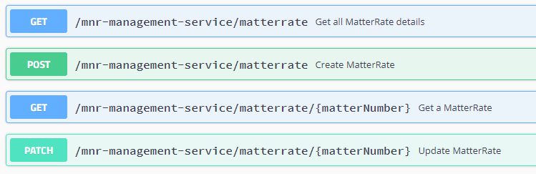
ITForms 007
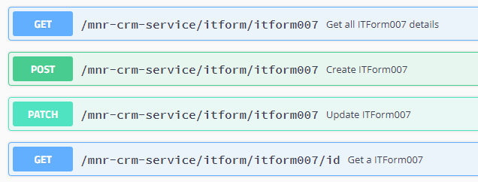
ITForms 010
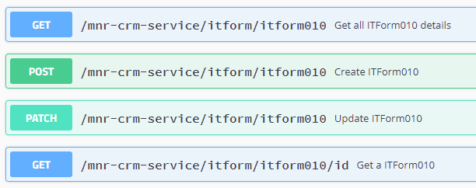
ITForms 011
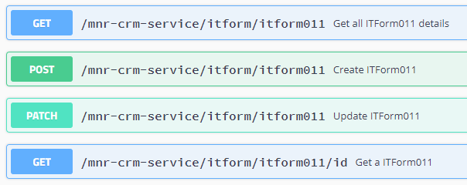
Docketwise Create Contact
Docketwise Contact Update
Docketwise Create Matter
Docketwise Matter Update
Docketwise GET API for Matter

